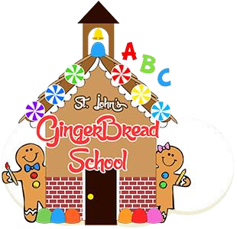

St. John’s Gingerbread School
1288 S. Indiana Avenue
Crown Point, IN 46307
(219) 663-7955
Email- info@stjohnsgingerbreadschool.org
Website- www.stjohnsgingerbreadschool.org

GINGERBREAD SCHOOL 2026-2027

Gingerbread Juniors (for 2 year olds before August 1st) –
This one hour, once a week program is aimed at social development. We incorporate hands-on activities and include many projects designed to stimulate academic curiosity and growth that entertains as well as promote interaction with others. Our goal is to have a room filled of age-appropriate activities for a two year old to learn how to play, share, and to be happy at school. In this class we will work with the children on fine and gross motor skills. This will be a fun play based hour away from parents! *If students are not potty trained, parents need to stay on premises*

___ A.M. Gingerbread Junior Program (Tues. 9:30-10:30) 1 hour Monthly Tuition $75.00

- 2026-2027 School year Registration fee for each child is $30 (Nonrefundable) This fee will guarantee your child a place in the class you choose. You can pay with cash or please make check or payable to “St. John’s Gingerbread School.” • There are two semester supply fees, $15 that will be charged in September and another $15 in January.
- In order for your child to attend Gingerbread school this fall, please return this form to us, along with your registration fee ($30)

Childs Name: __________________________________________________ Age:_____ Birthdate: __________________
Parent Name: __________________________________________Signature: ___________________________________
Phone Number: __________________________ Email: ____________________________________________________
Address: __________________________________________________________________________________________
Referred by:_________________________________________________________________ Date:_____/_____/______

*Parent Orientation Night will be in late August for all registered students’ Parents/Guardians. Our Meet & Greet Play Day (a day for Students & Parents to see the classroom, meet their teachers & classmates) will also be in late August. You can also watch our Facebook page. All Classes start the week of Labor Day.

OFFICE USE ONLY: Paid with- ____________________________ Staff initials- __________ | MAKE COPY FOR PARENT/GUARDIAN

